Code Review: I2303348
Reviewer: Mark Dell
Date: July 4th, 2023

Bugs
- In frmSalesOrder.vb, on line 7507, you added “OrderEntryLibrary.ShowWorkbook()” to the Else block of the “If mnuViewPriceList.Checked Then” statement. This appears to be contrary to the purpose of the else block of that if statement.
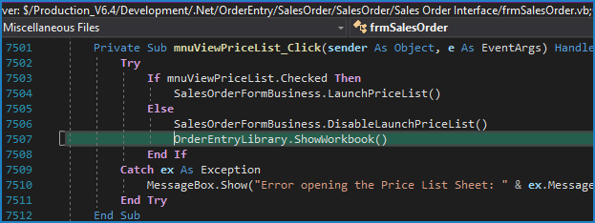
- In OrderEntryLibrary.vb, on lines 4645-4648, You changed it from “CloseWorkBook(False, True)” to “If sFile.Contains(_ExcelApp.WorkbookName) Then”, which means it will do a partial match, so if “PriceList.xlsm” was open, it would match if sFile was “VendorPriceList.xlsm”, but would fail if there was a case difference in the name, even if the names were otherwise identical. This could cause it to match when it should not, and not when it should. It also ignores the possibility of the paths being different. In addition, I believe that it was previously closing the workbook to address a broken reference issue, where the instance of excel was killed or otherwise not accessible, but the code still referenced it.
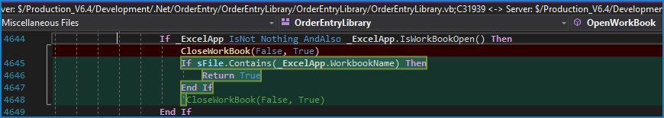
- On line 4683, you removed the “CloseExcel()” command, which means that if this opens a new copy of Excel, the previous copy will no longer be closed. This might be ok if on lines 4651 to 4655 it used the existing instance instead of always creating a new one.
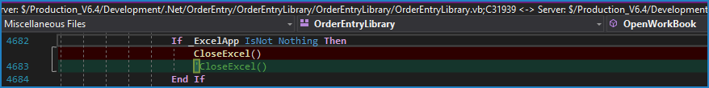

Preventative Action/Safety
- In frmEstimating.vb, on lines 285-290, you changed it to read the value from the registry, put it into a string variable, and then use CInt() to set the value for the SetSize variable. It would be simpler and easier to use Integer.TryParse() to directly convert the registry value to the expected integer. E.g. Integer.TryParse(CommonService.LoadSettingFromRegister("Estimate", "HeaderSpacing"), SetSize)
See: Int32.TryParse Method (System) | Microsoft Learn (Int32 is Integer)
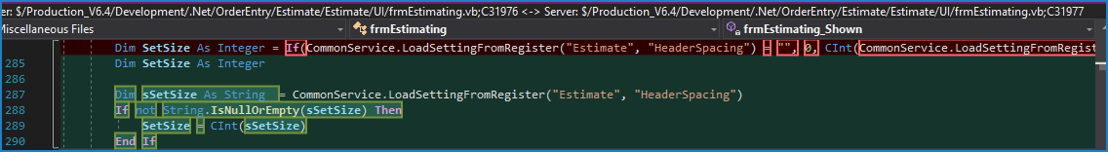

Design/Architecture (Duplication, appropriate project, namespaces, maintainability)

Data Model (Naming, good design, needs index?)

Performance (Minimize DB hits, excessive loops, queries, scalable)

UI (Alignment, naming, standardization, tab order)

Error Handling (Behind events, appropriate parameter checking)

Cleanup (Dispose code, remove handlers, large data objects)

Readability (Well-named variables, methods, clear algorithm, is it understandable)
- In OrderEntryLibrary.vb, lines 1442 to 1444, you created a copy of the “GetUnitCost” method, commented out, however that method has no changes when compared to its previous version. In addition, unless there is a specific documented reason (a comment in the code), we no longer keep old versions of code in the file, commented out. Having this implies there was a change when there was none, thus hampering readability.
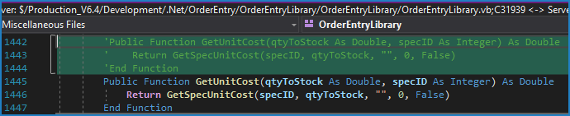
- In the new method created starting at line 4191, you have commented out code in the check-in. Unless there is a noted reason for this, it should not be included.
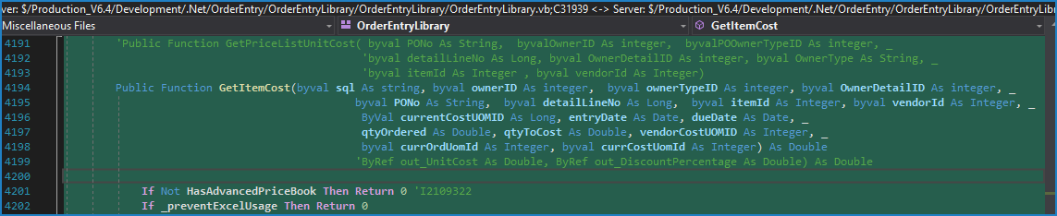

- In that same method, you have a finally clause that at one time closed the workbook and disposed of the “_ExcelApp” object. Since it no longer does this, this entire Finally clause, and thus the entire Try wrapper is not needed.
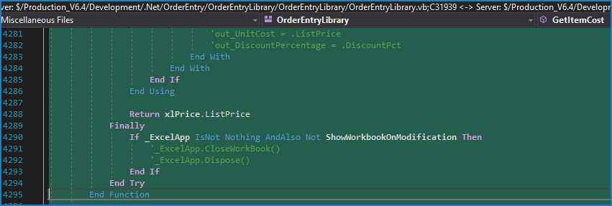
- In the method “Public Function ShowWorkbook() As Boolean”, lines 4695 to 4699 were added which appear to change the purpose of this method, because there is a controlling property/field, “ShowWorkbookOnModification” that optionally stops it from being shown. It seems, based on that name, that the workbook can only be shown if a change to it was made (e.g. Input!A4 was changed). If that was the intent, then the method name should be changed to reflect this, otherwise it will be used incorrectly by other developers.
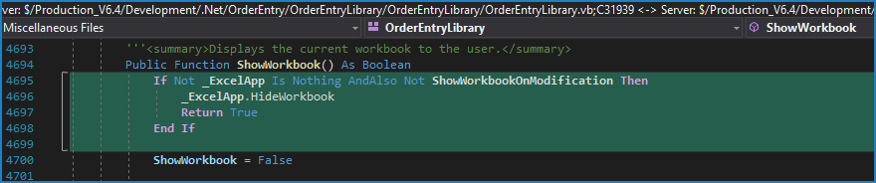
- Nit: Some keywords are specified using all lower case (e.g. “byval” on line 4537) instead of their correct casing.
- In clsPurchasing.vb, you changed “If OrderStreamConnections.GlobalConnection.ActiveMCN Is Nothing Then” to “If isNothing(OrderStreamConnections.GlobalConnection.ActiveMCN) Then”. We have decided as a group that we should be using the “Is Nothing” statement instead of the “IsNothing()” method. In addition, checking the “ActiveMCN” will cause OrderStreamConnections to “repair” the “broken” connection and ensure it is created. In some cases, in the past, this was done prior to setting the RuntimeEngine and thus it would connect to the wrong db, or throw a connection exception because the default “sxRuntime” could not be found.
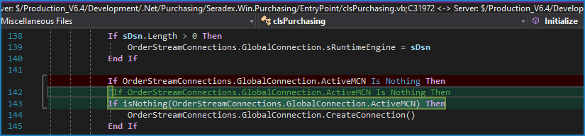

Comments (Useful, explains why rather than how)

Message Boxes (Grammar, spelling, captions, appropriate icons)

Ticket Management (Release Branch?, Testing Notes)

Extras

